# DOS LAB ASSIGNMENT- 01

1. Write the commands to create the following directory hirarchy: -> DOS_Regdno ->DOSass1->dir1

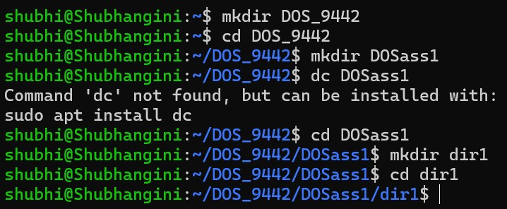

1. Write the commands to create another directory with name dir2 in directory DOSass1 and make dir2 as the current working directo

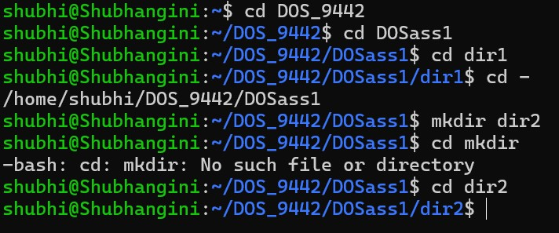

3.Write the command to delete the directory dir2 , when DOS_Regdno will be the current working directory.

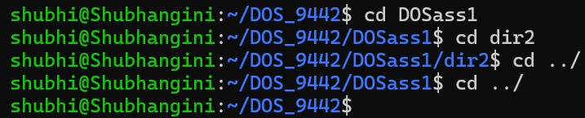

4.Write the command to create a file named as file1 using cat command inside dir1. Write your name, regdno, branch, semester and section in file1. Then display the content of the file.

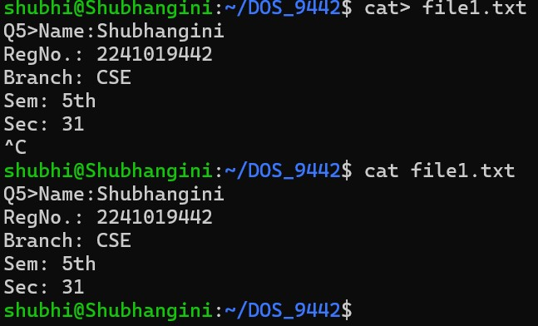

5. Write the command to create a file named as file2 using cat command inside dir1. Write your semester wise SGPA in file2.

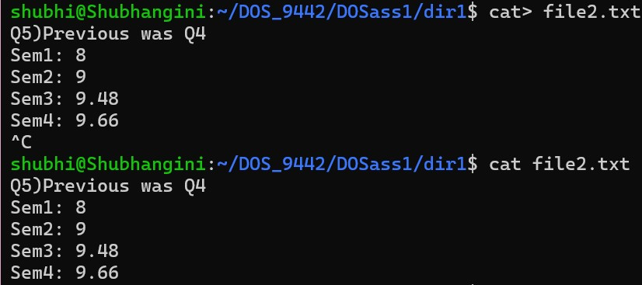

6.Create a file named as file3 storing content of file1 merged with content of file2.

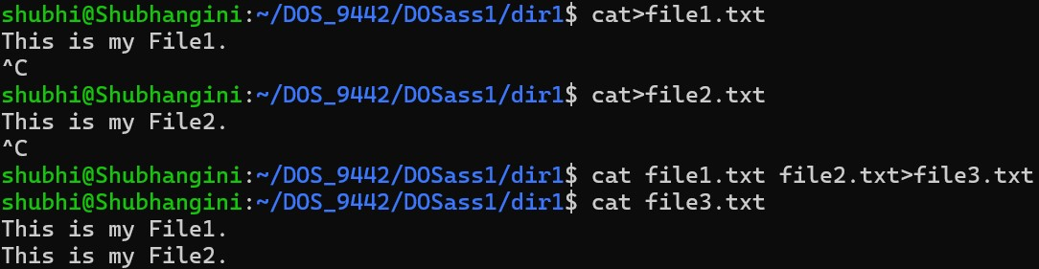

1. Write the command to rename file2 as markinfo. (mv – to rename)



1. Write the command to copy the content of file1 to reginfo. (cp- Copy)



9.Write the command to display the inode (index Node)values of file1,markinfo, reginfo.



10. Write the command to delete file1. (rm – to remove/delete)

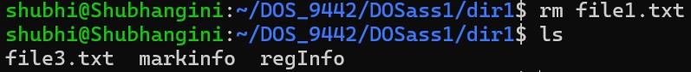

11.Write the command to count the number of lines, words, characters in markinfo.(wc - wordcont)



1. Write the command to create a file named as Personalinfo inside dir1. Write your name, regdno, address in the file.

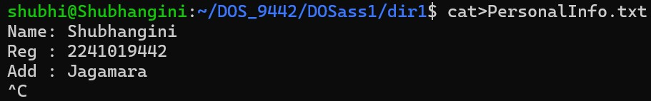

1. Write the command to display the content of markinfo in reverse order.

Command : sort –r filename.txt

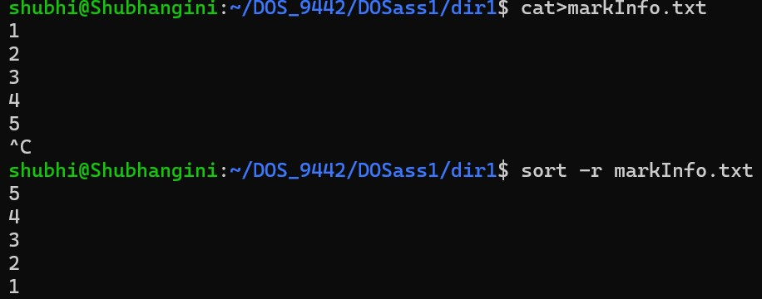

1. Check the output of the following command: cmp reginfo personalinfo diff reginfo personalinfo

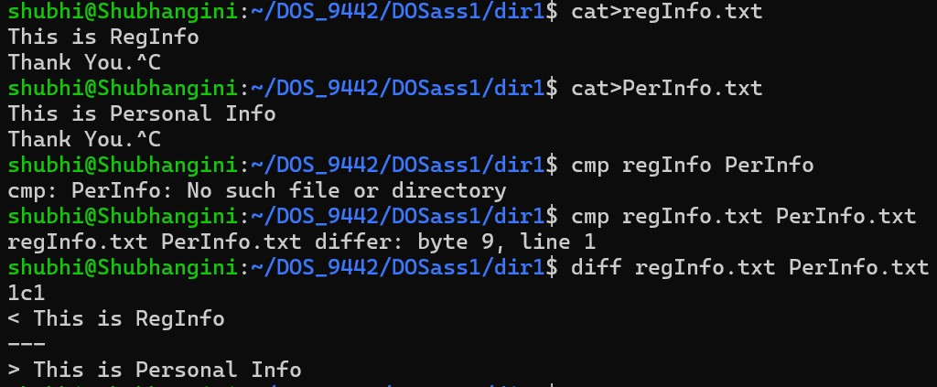

1. Write a command to count the number of files in the current working directory and display that number.



1. Write a command to include all the file names present in a current working directory in a file named as filelist without causing filelist to be included in the names.

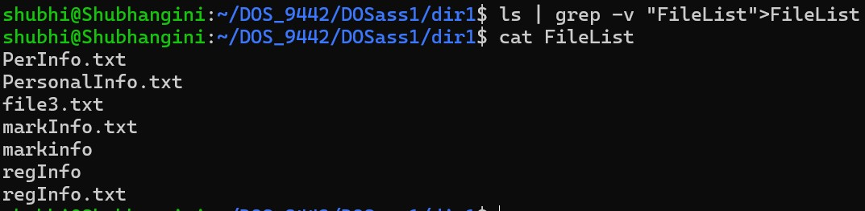

17. Write a command to give write permission to all the users of file reginfo.

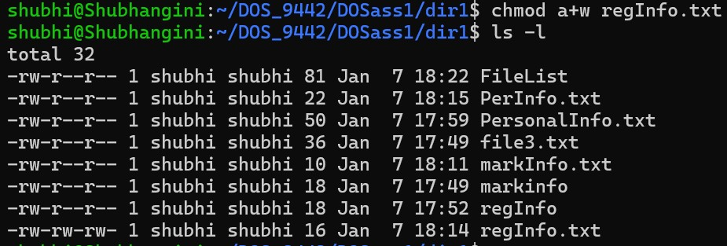

18.Write a command to discard write permission from group users group users of file reginfo.

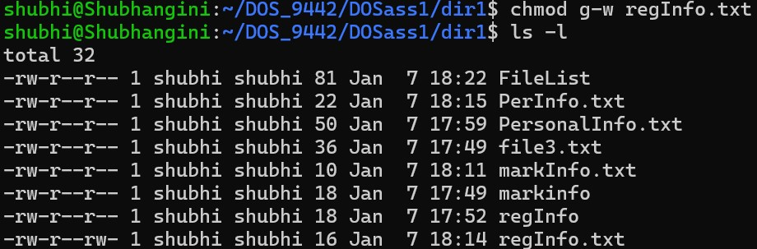

19. Write the command to set rwx permissions for all the users of file reginfo.

* 7 for the owner (read, write, execute).
* 7 for the group (read, write, execute).
* 7 for others (read, write, execute).

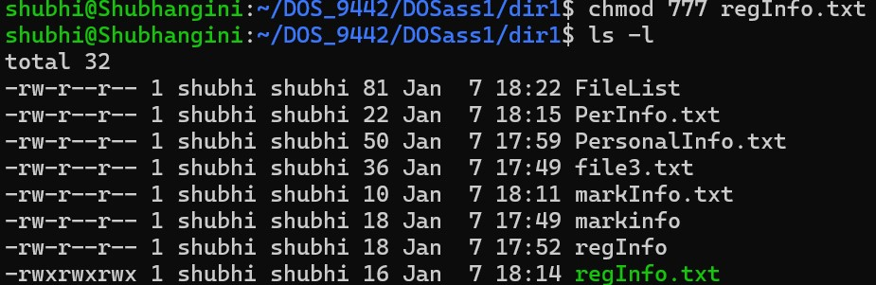

1. Differentiate between following commands:

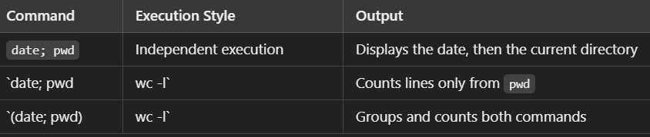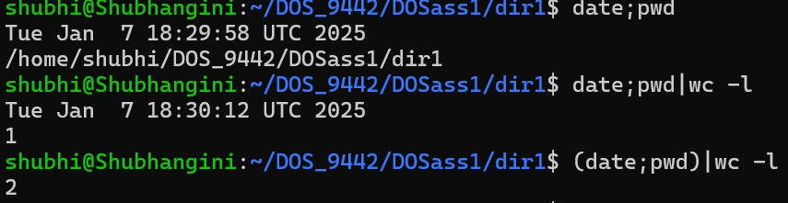

1. Interpret the output of the following commmands:

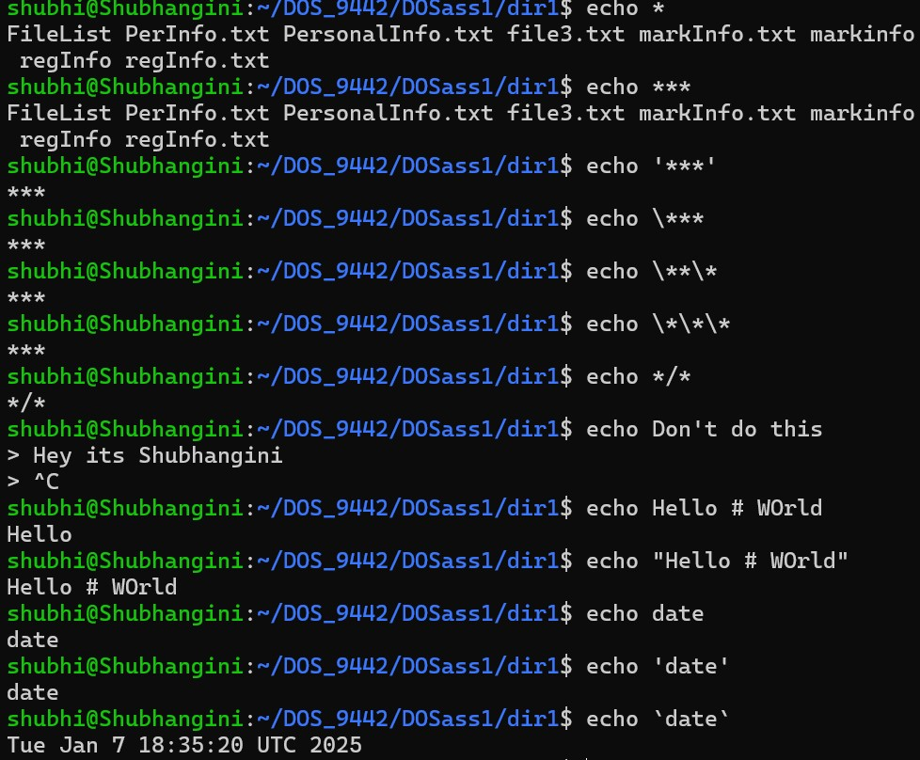

# DOS LAB ASSIGNMENT- 02

1.Write a shell script named as prog for merge the content of files a.txt, b.txt, and c.txt sort them and save the result in a file called result and display the sorted output on the screen.

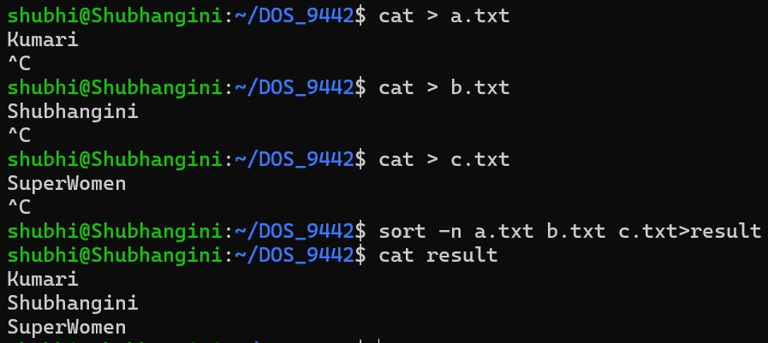

1. Write a shell script named as systeminfo that will display the information about the login name of the user, name of the Unix system used by the user, type of the SHELL, Path of current working directory of the user and list of file contain in current working directory.

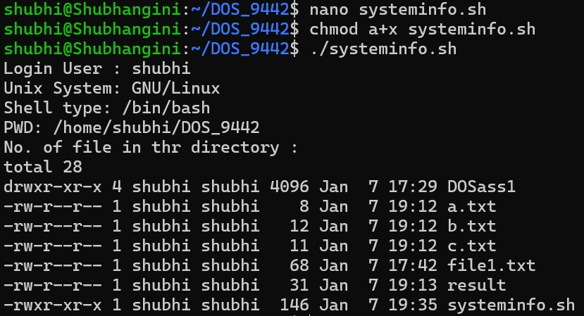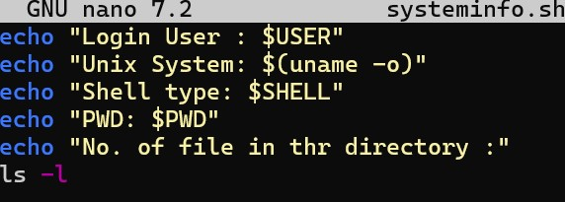

1. Write a shell script named as dtcal for displaying both the system date and calendar for specific month, say march 2022, in the given format:-Date : specific date Calender : current calender.

r

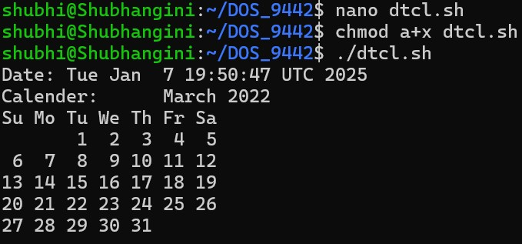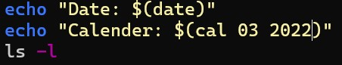

1. Write a shell script named as nvwc which will display the filename and linecount,wordcount and char count of the file dtcal in the following format: Filename: dtcal Line count: - Word count: - Charcout: -

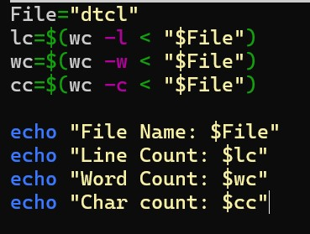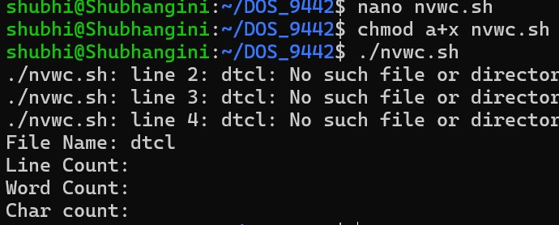

1. Write a shell script named as nvwc2 which will display the filename and linecount, word count and char count of any file given as argument to nvwc2 in the following format: filename linecount , wordcount , charcount file1 - - -

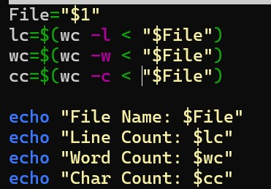 Same as Q4

6.Write a shell script named as darg to display the total number of command line arguments along with the first two arguments. -Modify the script to display all the arguments.

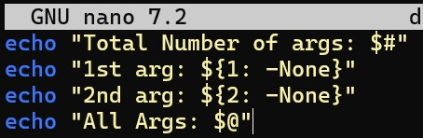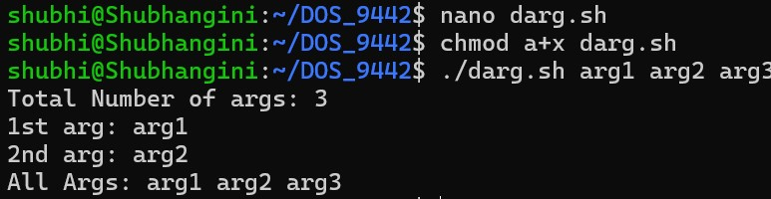

7. Write a shell script named as ndisp that will take three command line arguments specifying the value of n, m and a filename and display the first n number of lines and last m number of lines of the file given as argument.

